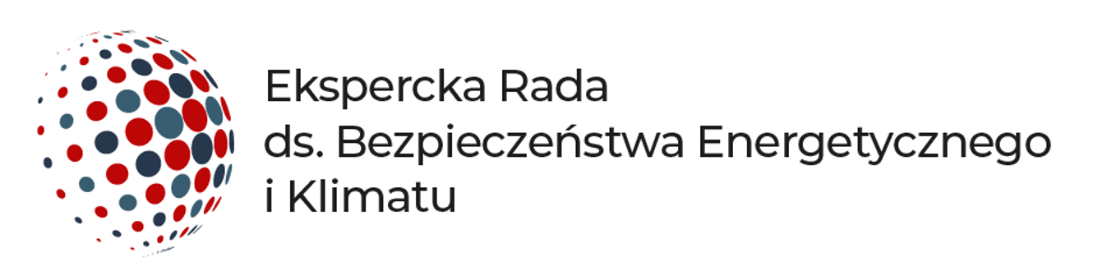

Warsaw, 29 June 2022.

PRESS RELEASE

The Expert Council on Energy Security and Climate is being established. The Council was formed at this turbulent moment, with the Russian war in Ukraine and when many principles and old beliefs are being re-evaluated. The aim of the Council is to support processes that strengthen energy security and the transition in Poland. The initiators of the project are Monika Morawiecka from the Regulatory Assistance Project and Joanna Maćkowiak-Pandera from Forum Energii. More than 20 energy experts were invited to join the Council.

The first topic addressed by the Council in June is recommendations on the assumptions for the update of Poland’s Energy Policy until 2040 and the current energy situation.

Context
In recent weeks, as a result of Russia’s full-scale invasion of Ukraine, a major re-evaluation has been rapidly taking place, with the approach to security, international cooperation, and energy policy changing before our eyes. This is a crucial moment in history, and wise decisions are important.
In energy matters, the priority has become independence from Russian commodities supplies in the shortest possible time. This concerns not only Poland but also the entire European Union. We are in the midst of a deep fuel crisis and, at the same time, the problems of the energy sector, including heating in its broadest sense, are not just going to go away, they are getting worse, with rising energy prices, ageing coal-fired power stations, declining power station availability, high emission levels from generation units, and, as a result of all these, worsening competitiveness of the economy. Added to this are the rapidly rising heating fuel prices, air pollution, and the need to protect the climate. The burden on energy consumers is increasing, and there is a risk that with so much change, we will lose sight of the fundamental goal, which is to ensure a secure, low-carbon and cost-effective supply of energy and heat to all consumers. Everything must be done to ensure that the crisis strengthens the Polish economy and society and improves energy security.

First Council Recommendations - PEP 2040

Poland’s preparation for passing through this difficult period depends on correct diagnoses and accurate and well-coordinated decisions on the part of the government, local governments, and businesses. The recommendations on the assumptions for updating PEP 2040 were adopted unanimously by the Council members after an in-depth discussion.

Main conclusions and recommendations of the Council:

- In the current conditions of the war in Ukraine and the cutting off of supplies of Russian raw materials, the priority in the short-term perspective—the coming winter—is ensuring secure, stable supplies of electricity and heat, as well as raw materials of natural gas, coal, and oil at prices that Polish society and economy will be able to bear.
- Citizens should be aware of the situation and be prepared for it. The Council recommends launching a nationwide public campaign to mobilise the public to save energy in electricity, heat, and fuel in transport.
- The energy crisis cannot stop the energy transition. The most important thing is systemic action to reduce the use of fossil fuels over the next few years, including by accelerating the development of renewables and electrification in the heating, transport, and industrial sectors.
- Energy efficiency improvements (e.g., thermomodernisation of buildings, use of waste heat) need to be stepped up. It is necessary to urgently revise the Long-Term Building Renovation Strategy adopted in February 2022 and to accelerate the announced pace of retrofitting and implement or reform support programmes.
- Poland should accelerate the development of RES as much as possible. In 2030, at least 50% of net electricity demand should come from renewable sources. It is necessary to abolish administrative barriers to the development of these sources, maintain reasonable incentives for development and change the organisation of the energy market so that the energy system is flexible and operates safely when the share of variable sources increases rapidly.
- The key is industry, the backbone of the economy, which is simultaneously exposed to many risks including rising fuel prices and disrupted supply chains. When energy supplies are threatened, industry will be the first to be subjected to constraints. It is therefore urgent to prepare paid demand-reduction mechanisms so that jobs are affected as little as possible.
- Cost-effective use of the existing coal-fired generation infrastructure will be important. However, there is no doubt that Poland must continue to plan for its energy transition and reduce the role of fossil fuels in the power sector. Fossil fuels will be very expensive in the years to come.
- Gas should be treated only as a complementary fuel. Poland should take measures to limit the use of gas in economic sectors, including in heating, industry, transport, and electricity.

The full content of the Council's position statement with examples of recommended actions is available on the dedicated website at rada-energetyczna.pl.

In the following weeks, the Expert Council on Energy Security and Climate will work on further recommendations to prepare our country for the passage of the energy crisis.

Purpose of creating the Council

The objective of the Expert Council is to support decision-making processes in areas of key importance to the improvement of Poland’s energy security and climate protection. The Council operates by publishing recommendations on strategic issues. The Council will discuss and recommend solutions concerning the directions of energy policy, energy and climate plans, but also distribution networks, energy efficiency, and heating in the broad sense.

Comments

- “Assumptions to the update of Poland’s Energy Policy correctly identify the directions Poland’s energy transformation should follow, emphasising the role of renewable energy sources and energy efficiency in ensuring security and sovereignty. Now it is time to set concrete and ambitious goals and to implement them quickly,” argues Monika Morawiecka of the Regulatory Assistance Project.

- “We are committed to showing viable solutions, but also long-term directions. In these difficult times, we are counting on wise decisions that will increase Poland’s resilience to crises—energy and environmental. We want to leave our children to live in a safe world where there is no shortage of energy," Dr Joanna Maćkowiak-Pandera of Forum Energii said.

Composition of the Council

The Council is made up of about 20 experts. The individuals invited by the initiators to join the Council represent different points of view and have many years of experience in key areas of energy: energy companies, business, state administration, industry, consulting, science, heating, think tanks and other institutions. At the same time, the Council has been shaped to avoid conflicts of interest in the institutions that are currently responsible for implementing the state’s energy strategy.

The Council is composed of: Dr. Joanna Maćkowiak Pandera and Monika Morawiecka, as well as Piotr Arak, Maciej Burny, Rafał Czyżewski, Dorota Dębińska-Pokorska, Łukasz Dobrowolski, Robert Jeszke, Henryk Kaliś, Prof. Janusz Lewandowski, Agata Łoskot-Strachota, Jacek Misiejuk, Paweł Musiałek, Wojciech Myślecki, Remigiusz Nowakowski, Grzegorz Onichimowski, Bogusław Regulski, Janusz Reiter, Jarosław Rot, Prof. Paweł Ruszkowski, Dr. Paweł Skowroński, Prof. Konrad Świrski, Paweł Wróbel, and Dorota Zawadzka-Stępniak.

Mode of operation

The Council will meet several times a year, decide together on priority topics, and agree on recommendations, which will then be published on a dedicated website and communicated to decision-makers.

The Council operates on a non-profit basis and does not promote any specific technologies or companies. It is apolitical and does not speak on personal or party issues. The people who make up the Council present their own views and not those of the institutions to which they are affiliated.

Contact

Klaudia Wojciechowska, External Relations Manager
klaudia.wojciechowska@forum-energii.eu
+48 691 022 426

Aleksandra Dziadykiewicz, Communications Manager
aleksandra.dziadykiewicz@forum-energii.eu
+48 573 378 898

